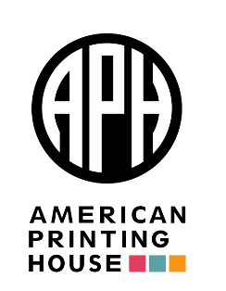

Dear Ex Officio Trustees, Assistants, and Parents,

Beginning in 2018, the federal government ruled that parental consent forms would be required for your students to be registered in the Federal Quota Program. Some of you have expressed concerns regarding how data collected from these forms is used.

The information obtained from the consent forms is to meet the requirements set forth by the U.S. Department of Education, in order to be included in the Federal Quota Program. However, personally identifying information (PII) is not sent, or required to be sent to the U.S. Department of Education or any federal government agency. This information is collected for statistical purposes only, and is not shared with any other entities or for any other purpose. Additionally, American Printing House (APH) does not keep the data beyond one year.

It is our hope that this letter may provide some additional assurance on how student data is used. Feel free to contact your Census Data and Information Manager & EOT Liaison, Cindy Amback, with any questions you may have.

We appreciate all you do to ensure that educational materials make it into the hands of the students we serve.

Respectfully,

Leanne Grillot Cindy Amback
Director of Outeach Services Census Data and Information Manager & EOT Liaison
American Printing House for the Blind
502-899-2257/800-223-1839
1839 Frankfort Avenue • Louisville, KY 40206
lgrillot@aph.org • camback@aph.org • info@aph.org

